Practicum Case | 
COMP7116 | COMP7116001 | COMP7116016 | MATH6168 | MATH6168016
Computer Vision
Computer Science | O221-COMP7116-WB01-01
Valid on Odd Semester 2024/2025 | Revision 00

Learning Outcome
- LO1 – Describe various computational principles and standard image processing operators in computer vision

Topic
- Session 3 – Image Processing

Sub Topics
- Graysacle
- Filtering
- Threshold

Soal
Case
WarioBros
WarioBros is one of the best gaming-fictional characters that consists of two brothers named Mario and Luigi. Maybe all of you already known their name because their popularities when we were little and used to playing console games. Your friends, Wilbert is one of the biggest fans of them. He have tons of Mario and Luigi images. Right now, he wants to make a poster of them but in grayscale, and want to blurring it a little bit to make it looks aesthetics. So, you as a professional programmer wants to help Wilbert by creating a filtering and threshold for the characters using Python Programming Languange and OpenCV library.
- Filtering
- Make a program to do 4 kinds of Filtering, which are Mean, Median, Gaussian, and Bilateral Filtering. Make sure to use the assets given on this case. Don’t forget to plot all of the results.
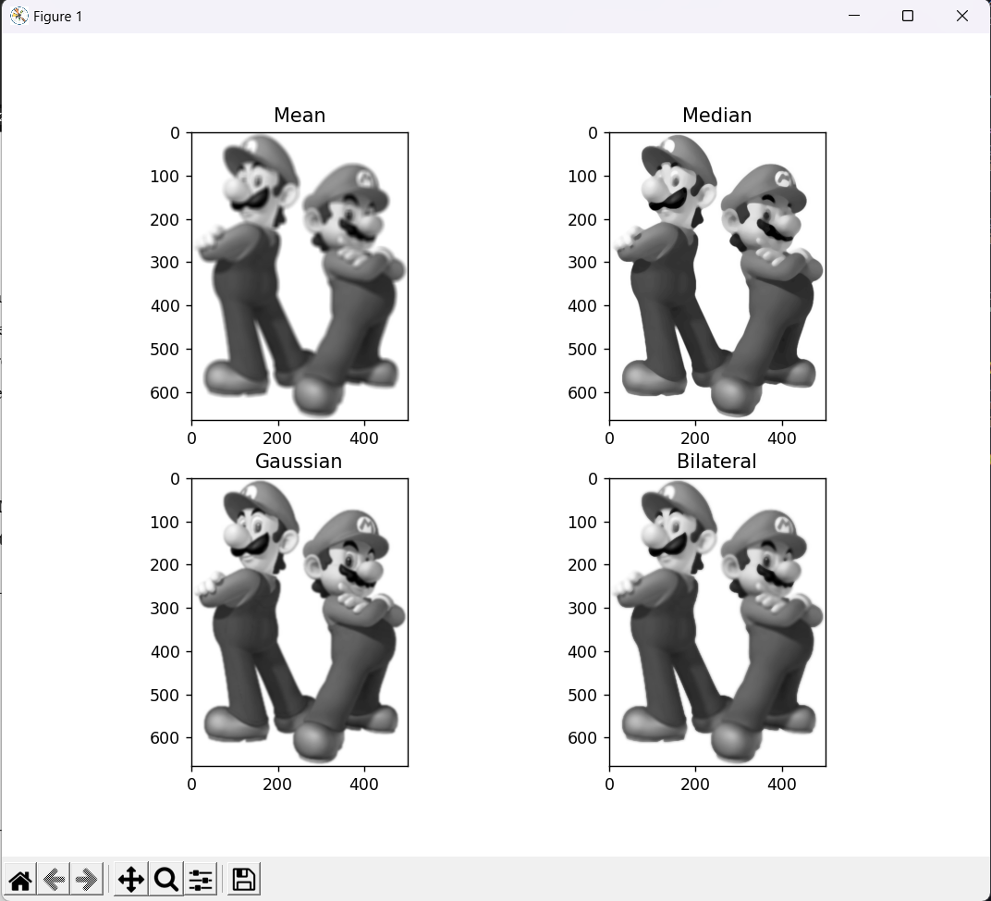
Figure 1. Example of Filtering Plotting
- Thresholding
- Make a program to do 6 kinds of Thresholding, which are Binary, Binary Inverse, Tozero, Tozero Inverse, Truncate, and Otsu Thresholding. Make sure to use the assets given on this case. Don’t forget to plot all of the results.
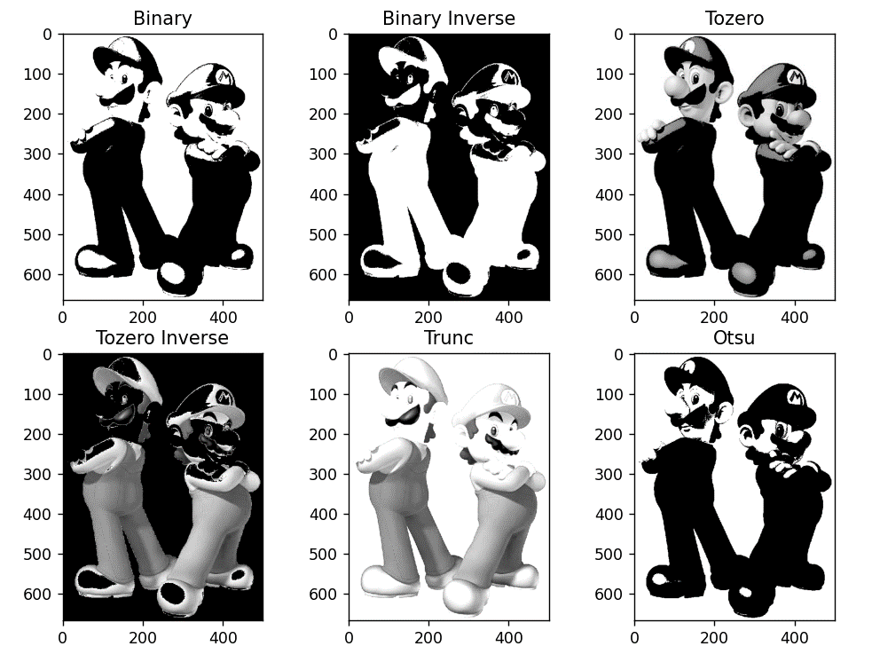
Figure 2. Example of Thresholding Plotting

